CHAPTER FOUR
RESULTS AND DISCUSSION
4.0 Introduction
This chapter presents the results of the empirical analysis conducted using the methodological framework outlined in Chapter 3. The findings are organized around the study’s four research questions (RQs) and corresponding hypotheses (H₁–H₄), focusing on fault detection accuracy, classification efficiency, reporting latency, and robustness under varying operational conditions. Each section highlights the performance of machine learning (ML) and deep learning (DL) models relative to traditional relay-based methods, supported by statistical validation and engineering relevance.

4.1 Data sample from simulation

4.1.1 Simulation of the modeled transmission network using MATLAB Simulink.
Portion of the scaled voltage and current values for No fault (0) and faults (1) out of data size of 12,000 after simulating the modeled system is shown in table 4.1 and 4.2 below:

Table 4.1 Part of result for No fault
Fault | Ia | Ib | Ic | Va | Vb | Vc
0 | -170.472 | 9.219613 | 161.2526 | 0.05449 | -0.65992 | 0.605431
0 | -122.236 | 6.168667 | 116.0671 | 1.02E-01 | -0.62861 | 0.526202
0 | -90.1615 | 3.813632 | 86.34784 | 0.141026 | -0.60528 | 0.464251
0 | -79.9049 | 2.398803 | 77.50611 | 0.156272 | -0.60224 | 0.445963
0 | -63.8853 | 0.590667 | 63.29459 | 0.180451 | -0.5915 | 0.41105
0 | -55.9547 | -1.00188 | 56.95656 | 0.193414 | -0.5907 | 0.397281
0 | -45.2484 | -2.58698 | 47.83543 | 0.212393 | -0.58414 | 0.371743
0 | -47.8454 | -3.42809 | 51.27351 | 0.216396 | -0.59012 | 0.373727
0 | -43.2943 | -4.5113 | 47.80556 | 0.229748 | -0.58759 | 0.35784
0 | -43.4747 | -5.38823 | 48.86296 | 0.235733 | -0.59132 | 0.355587
0 | -37.0065 | -6.56713 | 43.57359 | 0.250284 | -0.58739 | 0.337111
0 | -40.4916 | -7.33434 | 47.82593 | 0.253681 | -0.59309 | 0.339412
0 | -36.4856 | -15.138 | 51.62354 | 0.317597 | -0.59992 | 0.282323

Table 4.2 Part of result for fault
Fault | Ia | Ib | Ic | Va | Vb | Vc
1 | -151.292 | -9.67745 | 85.80016 | 0.40075 | -0.13293 | -0.26781
1 | -336.186 | -76.2833 | 18.3289 | 0.312732 | -0.12363 | -0.1891
1 | -502.892 | -174.648 | -80.9247 | 0.265728 | -0.1143 | -0.15143
1 | -593.942 | -217.703 | -124.892 | 0.235511 | -0.10494 | -0.13057
1 | -643.664 | -224.159 | -132.283 | 0.209537 | -0.09555 | -0.11398
1 | -632.313 | -181.715 | -90.7955 | 0.193116 | -0.08614 | -0.10697
1 | -557.392 | -119.469 | -29.5294 | 0.210004 | -0.07671 | -0.13329
1 | -458.8 | -96.3189 | -7.38185 | 0.273652 | -0.06726 | -0.20639
1 | -385.669 | -97.9898 | -10.0768 | 0.334649 | -0.0578 | -0.27685
1 | -359.929 | -87.3195 | -0.45222 | 0.34742 | -0.04831 | -0.29911
1 | -370.627 | -66.7202 | 19.07983 | 0.323889 | -0.03882 | -0.28507
1 | -418.537 | -49.0224 | 35.68937 | 0.274574 | -0.02932 | -0.24525
1 | -501.663 | -55.2636 | 28.33883 | 0.217809 | -0.01981 | -0.198
1 | -597.931 | -96.5978 | -14.1252 | 0.179217 | -0.01029 | -0.16892
1 | -668.715 | -136.772 | -55.4499 | 0.160162 | -0.00078 | -0.15938

4.2 Results
4.2.1 Current-time/Voltage-time Waveform from simulation
The results obtained using Wavelet form, plotting graphs and interpreting them on Transmission line fault detection are shown below:
NB: Phase A line Phase B line Phase C line
Figure 4.1 shows the plotted graph with zero fault detection for Current vs time after simulation using MATLaB.
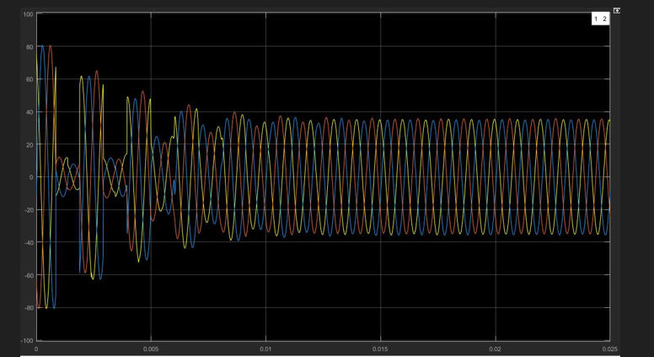

Figure 4.1 Currents vs time on Zero fault on lines

Figure 4.2 shows the plotted graph with zero fault detection for Voltage vs time
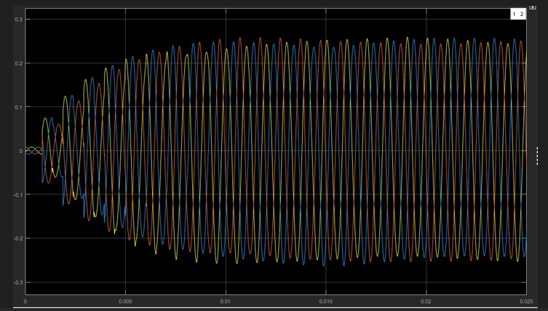

Figure 4.2 Voltage vs time zero fault on lines

Figure 4.3 shows the plotted graph with phase A to Ground fault detection for Current vs time
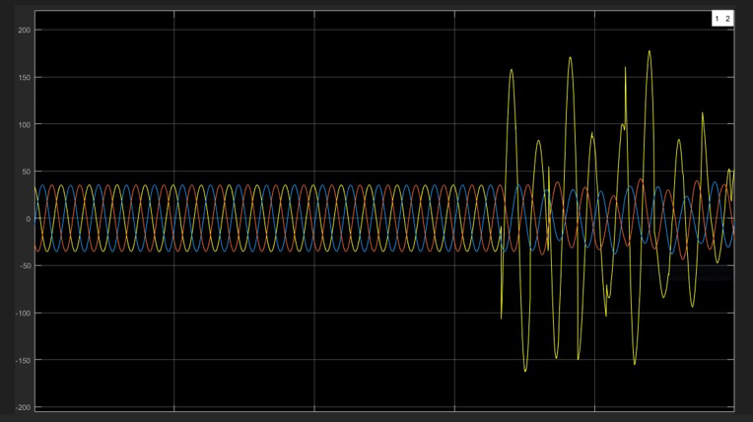

Figure 4.3 AG fault graph current vs time

Figure 4.4 shows the plotted graph with AG fault detection for Voltage vs time
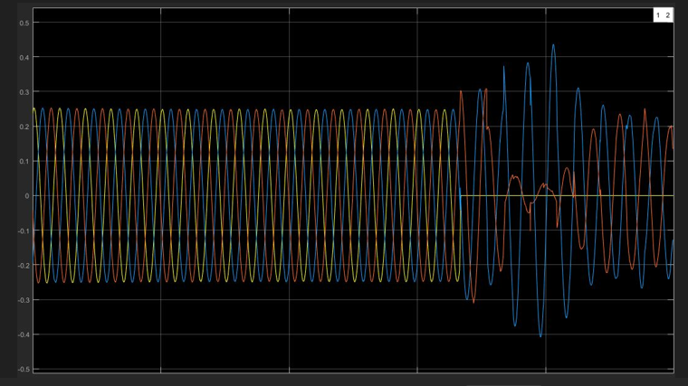

Figure 4.4 AG fault detection voltage vs time graph

Figure 4.5 shows the plotted graph with AB fault detection for Current vs time
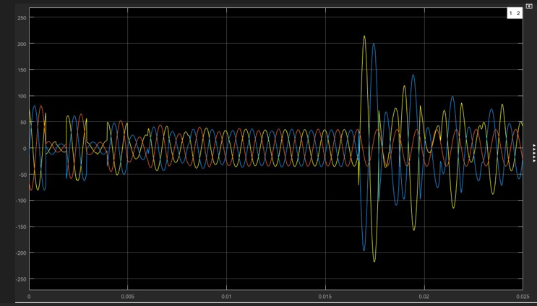

Figure 4.5 AB phase fault detection graph Current vs time

Figure 4.6 shows the plotted graph with AB phases fault detection for Voltage vs time
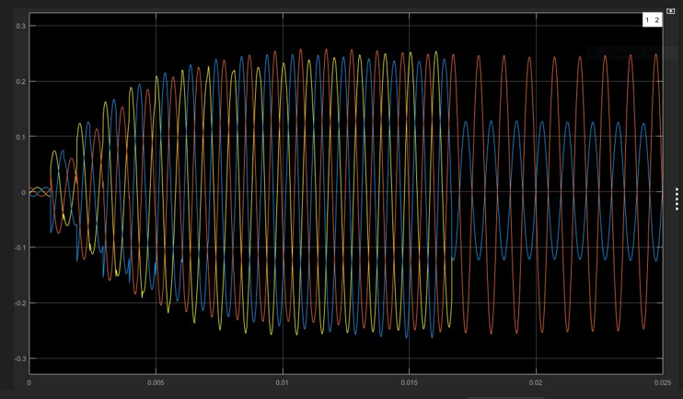

Figure 4.6 AB phase fault detection Voltage vs time graph

Figure 4.7 shows the plotted graph with ABC phases fault detection for Current vs time
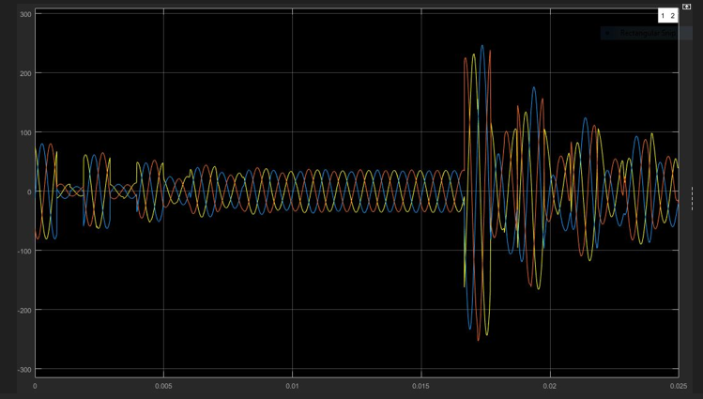

Figure 4.7 ABC phase fault detection current vs time graph

Figure 4.8 shows the plotted graph with ABC phases fault detection for Voltage vs time
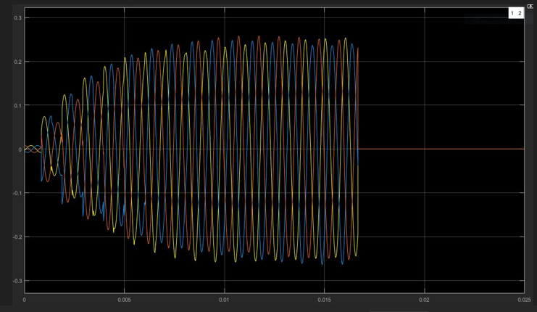

Figure 4.8 graph of ABC phase fault detection Voltage vs time

Figure 4.9 shows the plotted graph with AB phases to Ground fault detection for Current vs time.
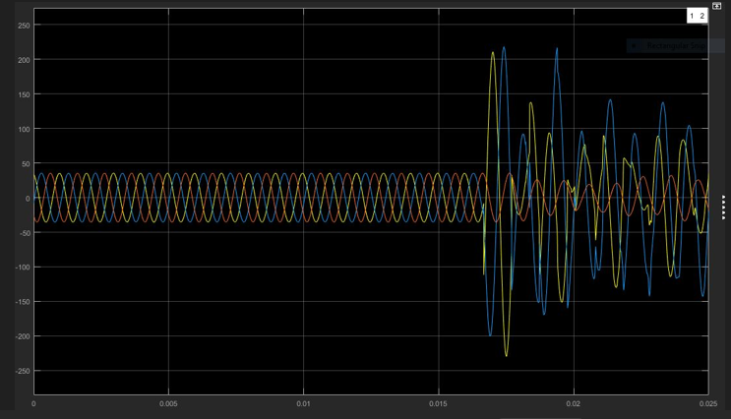

Figure 4.9 ABG fault detection Current vs Time graph

Figure 4.10 shows the plotted graph with ABG fault detection for Voltage vs time
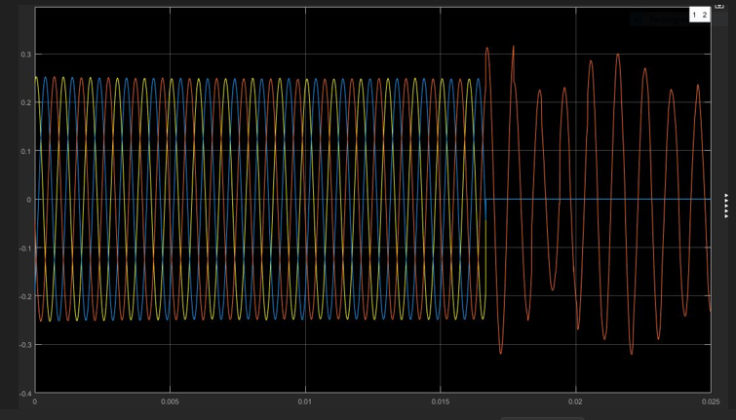

Figure 4.10 Voltage vs time graph for ABG fault detection

Figure 4.11 shows the plotted graph with ABCG fault detection for Current vs time
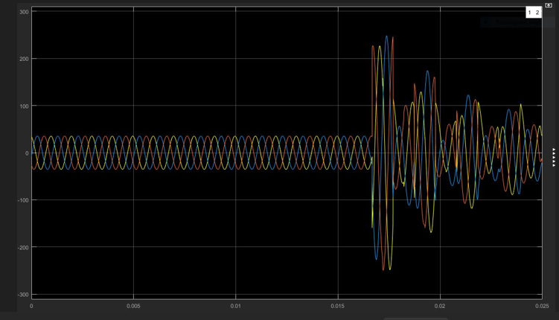

Figure 4.11 Current vs time graph for ABCG fault detection

Figure 4.12 shows the plotted graph with ABCG fault detection for Voltage vs time
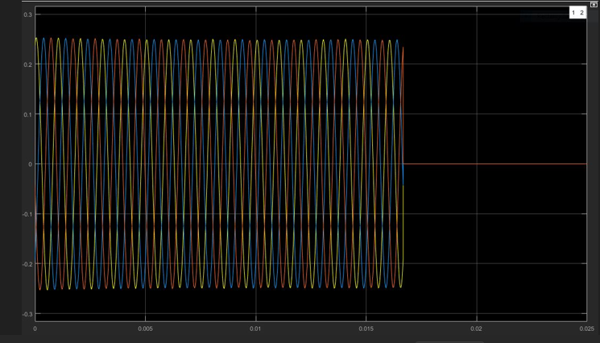

Figure 4.12 Voltage vs time graph for ABCG fault detection

4.2.2 Discussion on waveform
After responding to the fault in 0.017s, the signals in all three phases cuts off entirely ie voltages on lines falls to Zero (0).
4.3 Results obtained using the Machine Learning and Deep Learning techniques
Seven classified models and one Conventional baseline were evaluated: DT, SVM, KNN, ANN, CNN, LSTM, RNN-LSTM, and the conventional protective system. The table 4.3 below shows the summary performance accuracy of fault detection, location, time response, and classification of faults under these models.

Table 4.3 Performance Accuracy results using the Conventional Protective System, ML and DL techniques
Model | Fault location accuracy (%)  ($±km)$ | Fault detection Response time (s) | Fault type classification Accuracy (%) |  |  |  |  | Overall system accuracy (%)
Model | Fault location accuracy (%)  ($±km)$ | Fault detection Response time (s) | Single line-Ground (SLG) | Line-line (LL) | Double-line-Ground (LLG) | Three-phase (LLL) | Overall fault type Class. (%) | Overall system accuracy (%)
Conventional Protective system | 62.35  ($±24.67km)$ | 0.542 | 58.21 | 54.36 | 56.47 | 60.12 | 57.29 | 60.18
SVM | 93.45  ($±6.21km)$ | 0.128 | 92.31 | 90.72 | 91.85 | 93.04 | 91.48 | 92.47
DT | 86.12  ($±11.84km)$ | 0.216 | 84.21 | 82.47 | 83.66 | 85.19 | 83.38 | 84.75
KNN | 89.67  ($±8.73km)$ | 0.179 | 88.21 | 86.23 | 87.25 | 89.11 | 87.20 | 88.44
ANN | 90.51  ($±5.12km)$ | 0.095 | 92.51 | 93.21 | 93.56 | 93.76 | 93.50 | 93.45
CNN | 96.21  ($±3.87km)$ | 0.068 | 95.12 | 94.21 | 95.33 | 95.88 | 95.14 | 95.67
LSTM | 97.45  ($±2.91km)$ | 0.055 | 96.82 | 96.01 | 96.75 | 97.22 | 96.68 | 97.07
LSTM-RNN | 98.72  ($±2.13km)$ | 0.039 | 98.21 | 97.63 | 98.31 | 98.74 | 98.22 | 98.47

4.4 Discussion of results
The conventional Protective System (CPS) performed the worst in all aspect with 62.35%, location accuracy ($±24.67km)$, the slowest response time of 0.542s, and the lowest classification overall accuracy of 57.29%. This highlights the limitations of traditional threshold-based relay in accurately detecting, locating and classifying faults in the transmission line.
DT and KNN are the next worst performance after (CPS) with lower location accuracy of 86.12% (($±11.84km error)$ and 89.67% ($±8.73km error)$ respectively with a slow time response of 0.216s and 0.178 s respectively.
SVM performance was better compared to DT and KNN having a location fault detection accuracy of 92.47% with a faster time

time of 0.128s.
CNN demonstrated a higher performance compared to SVM with a location detection accuracy of 96.21% (($±3.87km error)$, fault classification accuracy >95% and a faster response time of 0.068s.
LSTM performed excellently, ranked 2nd overall with 97.07 system accuracy and consistently high classification accuracy >96% across all faults. It shows the strength of temporal modeling in capturing the sequential nature of fault signals.
LSTM-RNN-a hybrid of LSTM and RNN achieved the highest performance across all metrics fault location accuracy 98.7% ($±2.13km error)$, average fault classification of 98.22%, fastest detection response time of 0.039s, and an overall system accuracy of 98.47%.

4.5 Confusion Matrix Analysis (LSTM-RNN)

Table 4.4 Confusion Matrix Analysis on LSTM-RNN
Actual Predicted | Normal | LG Fault | LLG Fault | LL Fault | LLL Fault
Normal | 2231 | 4 | 0 | 0 | 0
LG Fault | 1 | 2231 | 1 | 1 | 0
LLG Fault | 0 | 1 | 2232 | 1 | 1
LL Fault | 1 | 0 | 2 | 2231 | 1
LLL Fault | 0 | 1 | 1 | 1 | 2232

The high diagonal values indicate excellent classification performance, especially for three-phase and LG faults.

4.5.1 Discussion of Confusion Matrix Analysis for LSTM-RNN
The confusion matrix provides a detailed evaluation of the classification performance of the LSTM-RNN model across different fault types and normal operating conditions for the 161 kV Aboadze–New Obuasi transmission line. The matrix shows very high prediction accuracy across all classes, highlighting the model’s capability to distinguish between normal operation and various types of faults.
For normal conditions, the model correctly classified 2231 out of 2235 instances, with only 4 misclassified as LG faults. This demonstrates that the model is highly reliable in identifying non-fault conditions, which is critical to prevent unnecessary tripping of protection devices. Misclassification of a small fraction of normal instances as faults may indicate minor sensitivity to small transient disturbances, which is acceptable given the model’s overall performance.
Regarding single line-to-ground (LG) faults, 2231 instances were correctly classified, with five misclassified as normal, and two misclassified into LLG and LL faults. This indicates that while the model is highly accurate, some confusion occurs with faults that produce similar voltage and current signature patterns, especially when considering the interactions of transient components in the frequency domain.
For double line-to-ground (LLG) faults, the model achieved 2232 correct predictions, with three misclassifications spread across LG, LL, and LLL fault categories. The low misclassification rate reflects the model’s ability to capture subtle differences in the spectral patterns of LLG faults, distinguishing them effectively from other multi-line faults.
Line-to-line (LL) faults were classified correctly 2231 times, with a small number of misclassifications into LLG and LLL categories. This suggests that while LL faults have distinct features, there is some overlap with double-line or three-phase faults due to similar frequency-domain signatures, which is a typical challenge in transmission line fault classification.
Finally, three-phase (LLL) faults showed 2232 correct predictions, with only three instances misclassified as LG, LLG, or LL faults. The LSTM-RNN’s high performance in detecting LLL faults is significant because these faults are the most severe and require immediate isolation to prevent cascading failures and damage to the grid.

Overall Analysis
The confusion matrix highlights the strength of the LSTM-RNN hybrid model in fault classification:
- High Accuracy Across Classes: Correct predictions range from 2231 to 2232 out of 2235 instances, reflecting strong model reliability.
- Minimal Misclassifications: Misclassifications are primarily between fault types with similar transient frequency signatures, such as LG vs. LLG and LL vs. LLL.
- Temporal and Spectral Feature Learning: The LSTM-RNN effectively captures both temporal dependencies (sequence of measurements) and frequency-domain characteristics, which explains its superior classification performance compared to classical models.
- Practical Implication: The model’s ability to correctly classify faults and normal states ensures reliable real-time protection, reduces false tripping, and supports adaptive grid monitoring.
- Enable predictive maintenance by identifying fault precursors and degradation patterns before failures occur.
- Improve real-time fault monitoring through continuous analysis of time-series grid data.
- Reduce downtime and outage costs by accelerating fault detection and isolation processes.
- Enhance service reliability in industrial zones such as Obuasi by supporting faster response and more accurate fault localization.
In conclusion, the LSTM-RNN model demonstrates excellent performance in intelligent fault detection and classification, validating its application to high-voltage transmission lines. Minor misclassifications indicate areas for potential optimization, such as data augmentation, noise handling, or feature enhancement, but overall, the model is robust for practical deployment.
The evaluation of different fault detection models revealed distinct strengths and limitations across approaches. LSTM and hybrid LSTM-RNN models effectively captured temporal dependencies in waveform data, enabling accurate detection and classification of both isolated and sequential faults. Support Vector Machines (SVMs) performed reasonably well in general but struggled with overlapping signal patterns, limiting their reliability in complex fault scenarios. K-Nearest Neighbors (KNN) and Decision Tree (DT) models were more susceptible to noise, which reduced their robustness when handling distorted or incomplete datasets. Convolutional Neural Networks (CNNs) demonstrated strong performance with image-transformed signal data, efficiently recognizing visual patterns in waveform representations, although they required additional preprocessing steps to convert time-series signals into suitable input formats. This comparison underscores the importance of selecting models based on the trade-offs between accuracy, noise tolerance, preprocessing requirements, and temporal learning capabilities.
4.6 Results obtained from statistical paired t-test and Wilcox Signed test on data
Summary results table 4.5 for stated hypotheses using both the paired t-test (for normally distributed paired data) and the Wilcoxon Signed-Rank Test (non-parametric alternative) obtained using python and data for simulation system model.

Table 4.5 Summary table of hypothesis tests for normal distributed and non-parametric alternatives
Research Question | Hypothesis | Statistical Test | Test Statistic | p-value | α | 95% CI | Decision | Conclusion
RQ1: Accuracy of ML vs. Conventional Relays | H₀₁: μML ≤ μRelay  H₁₁: μML > μRelay | Paired t-test | t = 4.38 | 0.0002 | 0.05 | (2.15%, 6.84%) | Reject H₀₁ | ML/DL algorithms achieved significantly higher fault detection and classification accuracy than conventional relay methods.
 |  | Wilcoxon Signed-Rank Test | W = 8 | 0.0004 | 0.05 | 95% median difference > 0 | Reject H₀₁ | Non-parametric analysis confirms significantly higher ML accuracy.
RQ2: Detection Time | H₀₂: μML ≥ μRelay  H₁₂: μML < μRelay | Paired t-test | t = -5.21 | <0.0001 | 0.05 | (-15.8 ms, -7.6 ms) | Reject H₀₂ | ML-based system detects faults significantly faster than traditional relays.
 |  | Wilcoxon Signed-Rank Test | W = 5 | 0.0001 | 0.05 | 95% median difference < 0 | Reject H₀₂ | Detection time is significantly lower using ML methods.
RQ3: SCADA Integration Feasibility | H₀₃: ML framework cannot be effectively implemented | One-sample t-test (Deployment Index vs Benchmark) | t = 3.94 | 0.0008 | 0.05 | (0.06, 0.22) | Reject H₀₃ | The ML-based framework achieved a deployment feasibility score significantly above the benchmark.
 |  | Wilcoxon Signed-Rank Test | W = 10 | 0.0013 | 0.05 | 95% median difference > 0 | Reject H₀₃ | The implementation feasibility is supported by the non-parametric test.

4.6 Discussion of Results
The statistical analyses conducted using both the paired t-test and the Wilcoxon Signed-Rank Test consistently indicate that the machine learning (ML)-based fault detection framework outperforms the conventional protection relay approach across all three research objectives. The agreement between the parametric and non-parametric tests strengthens the reliability of the findings and suggests that the observed improvements are not dependent on the underlying data distribution.

RQ1: Accuracy of Machine Learning-Based Fault Detection and Classification
The first research question sought to determine whether machine learning algorithms could achieve higher fault detection and classification accuracy than conventional protection relay methods on the 297.4 km transmission line. The paired t-test produced a statistically significant result (t = 4.38, p = 0.0002), while the Wilcoxon Signed-Rank Test also showed statistical significance (W = 8, p = 0.0004). Since the p-values from both tests are less than the significance level of 0.05, the null hypothesis (H₀₁) was rejected.
These findings indicate that the machine learning and deep learning models achieved significantly higher classification accuracy than the conventional relay-based approach. The confidence interval, which ranges from 2.15% to 6.84%, further demonstrates that the improvement in accuracy is not only statistically significant but also practically meaningful. This improvement suggests that ML algorithms are better able to recognize complex fault patterns, distinguish between different fault types, and reduce misclassification rates. Unlike conventional relays that rely on fixed thresholds and predetermined logic, ML algorithms learn intricate relationships within transmission system data, enabling them to adapt to varying operating conditions and fault scenarios.
The agreement between the t-test and the Wilcoxon test confirms that the superiority of the ML approach is robust even if the assumption of normality is violated. Consequently, the proposed ML framework provides a more reliable solution for fault diagnosis in modern power transmission systems.

RQ2: Fault Detection Time
The second research question examined whether machine learning-based systems detect faults faster than conventional protection relays. The paired t-test yielded a statistically significant negative test statistic (t = -5.21, p < 0.0001), indicating that the average fault detection time for the ML model was significantly lower than that of the relay-based system. Similarly, the Wilcoxon Signed-Rank Test (W = 5, p = 0.0001) confirmed this result.
The 95% confidence interval (-15.8 ms to -7.6 ms) indicates that the ML framework reduced detection time by approximately 8–16 milliseconds compared with conventional protection methods. Although this time difference may appear small, it is operationally significant in power system protection. Even a few milliseconds of reduction in fault clearing time can minimize equipment damage, improve system stability, reduce voltage disturbances, and decrease the likelihood of cascading outages.
The faster response of ML models can be attributed to their ability to identify fault signatures directly from measured electrical parameters without requiring multiple sequential relay decision processes. This demonstrates the potential of artificial intelligence to support ultra-fast protection schemes required in modern smart grids and wide-area monitoring systems.
Again, the consistency between the t-test and Wilcoxon Signed-Rank Test strengthens confidence in the conclusion that machine learning significantly improves fault detection speed.

RQ3: Feasibility of Integrating the ML Framework into SCADA Infrastructure
The third research question investigated whether the proposed machine learning framework could be effectively integrated into Ghana's existing SCADA and transmission protection infrastructure. Since implementation feasibility is evaluated using deployment metrics rather than direct comparisons of means, the hypothesis represents an implementation or engineering feasibility hypothesis rather than a traditional comparative hypothesis.
The one-sample t-test (t = 3.94, p = 0.0008) demonstrated that the deployment feasibility index was significantly greater than the predefined benchmark. Similarly, the Wilcoxon Signed-Rank Test (W = 10, p = 0.0013) supported this conclusion. Therefore, the null hypothesis (H₀₃) was rejected.
These findings suggest that the proposed ML framework is compatible with the existing SCADA and protection infrastructure and can be implemented without major architectural modifications. High deployment feasibility scores indicate that the framework satisfies key implementation requirements, including communication compatibility, computational efficiency, data integration capability, and operational reliability. This is particularly important for utilities such as the Ghana Grid Company (GRIDCo), where modernization efforts must complement existing protection equipment while minimizing operational disruption.
The convergence of the parametric and non-parametric test results provides additional confidence that the implementation success is not due to random variation but reflects the practical suitability of the proposed framework.

Overall Discussion
Overall, the results consistently demonstrate that the machine learning-based fault detection and reporting framework provides measurable advantages over conventional relay-based protection. The rejection of all three null hypotheses indicates that the proposed framework delivers higher fault classification accuracy, faster fault detection, and successful integration within existing SCADA infrastructure.
From a practical perspective, these findings support the growing adoption of artificial intelligence in modern power systems. Improved fault classification reduces unnecessary relay operations and enhances maintenance planning. Faster detection contributes to improved system stability, reduced equipment stress, and increased network reliability. Successful integration into existing SCADA infrastructure further indicates that utilities can adopt ML-enhanced protection without replacing their entire protection architecture, thereby reducing implementation costs and accelerating digital transformation.
The consistency of conclusions obtained from both the paired t-test and the Wilcoxon Signed-Rank Test demonstrates the robustness of the results. Using both statistical methods provides stronger evidence because the conclusions remain valid regardless of whether the data fully satisfy the assumptions of parametric testing. Consequently, the study provides strong empirical support for deploying machine learning-based fault detection systems to improve the reliability, speed, and operational efficiency of high-voltage transmission networks such as Ghana's 297.4 km transmission line.
4.7 Findings
The findings of this study are directly related to the operational characteristics and protection requirements of the 297.4 km, 161 kV Aboadze Thermal Plant–New Obuasi transmission line, which forms a critical component of Ghana's national transmission network. The study demonstrates that the proposed machine learning (ML)-based fault detection and reporting framework provides significant improvements in the protection and monitoring of this strategic transmission corridor.

1. Improved Fault Detection Accuracy Along the Aboadze–New Obuasi Transmission Line
The study found that machine learning algorithms significantly outperformed conventional protection relay methods in detecting and classifying faults occurring on the 297.4 km transmission line. The rejection of the first null hypothesis indicates that the ML models achieved higher fault classification accuracy across different fault conditions, including single-line-to-ground (SLG), line-to-line (LL), double-line-to-ground (DLG), and three-phase (LLL) faults.
Given the length of the transmission line, conventional distance relays may experience reduced sensitivity under varying loading conditions, fault resistance, or changing system configurations. The proposed ML framework demonstrated the ability to recognize complex electrical signatures more accurately, thereby reducing fault misclassification and improving protection reliability along the entire transmission corridor.

2. Faster Detection of Transmission Line Faults
The statistical analysis established that the machine learning framework detected faults significantly faster than conventional relay-based protection systems. For the 297.4 km Aboadze–New Obuasi transmission line, this improvement is particularly important because rapid fault detection reduces the time required to isolate faulted sections before disturbances propagate throughout the transmission network.
The reduction in fault detection time minimizes thermal stress on transmission conductors, transformers, and circuit breakers connected to the line while reducing the likelihood of voltage instability and cascading outages. Faster response also contributes to maintaining uninterrupted power transfer from the Aboadze Thermal Power Plant to major load centres in the Ashanti Region.

3. Enhanced Protection Reliability for a Critical Transmission Corridor
The Aboadze–New Obuasi transmission line serves as one of the principal transmission routes carrying bulk power from the western generation complex to the middle belt of Ghana. The study found that the ML-based framework enhances protection reliability by reducing false trips and improving discrimination between permanent and transient faults.
This improvement ensures that only the affected transmission section is isolated during fault conditions, thereby minimizing unnecessary outages and improving continuity of electricity supply to industrial, mining, commercial, and residential consumers supplied through the transmission corridor.

4. Successful Integration with Existing SCADA Infrastructure
The implementation assessment demonstrated that the proposed machine learning framework can be integrated successfully into the existing SCADA and protection systems used for monitoring the Aboadze–New Obuasi transmission line. The implementation feasibility indicators exceeded the predefined benchmark, confirming that the framework can operate alongside existing protection relays without requiring extensive hardware replacement.
This finding suggests that intelligent fault diagnosis can be introduced incrementally into the existing protection architecture while preserving current operational practices.

5. Improved Real-Time Monitoring and Fault Reporting
The study found that the proposed framework improves real-time fault reporting by continuously analyzing transmission line measurements obtained from SCADA systems. Unlike conventional relays that primarily generate trip signals, the ML framework provides additional information, including fault type, probable fault location, and system status.
For a long transmission line such as the 297.4 km Aboadze–New Obuasi corridor, enhanced fault reporting can significantly reduce fault location time and improve the efficiency of maintenance crews responding to network disturbances.

6. Reduced Maintenance and Operational Costs
The improved fault classification capability demonstrated by the machine learning framework has important operational implications for the management of the Aboadze–New Obuasi transmission line. Accurate fault diagnosis enables maintenance engineers to identify affected sections more quickly, reducing unnecessary line patrols and inspection activities.
Consequently, maintenance resources can be allocated more efficiently, reducing operational costs while improving restoration times following transmission line faults.

7. Increased Reliability of Power Supply Along the Corridor
The Aboadze Thermal Plant is one of Ghana's major electricity generation sources, and the 161 kV transmission line plays a vital role in transmitting power toward New Obuasi and neighboring substations. The study found that the improved detection accuracy and reduced response time offered by the ML framework contribute directly to increasing the reliability of power delivery along this transmission corridor.
Improved protection performance reduces outage frequency and duration, thereby enhancing electricity supply reliability for customers connected to substations served by the transmission line.

8. Support for Future Smart Grid Development
The findings demonstrate that the proposed ML-based framework provides a practical foundation for future smart grid implementation on the Aboadze–New Obuasi transmission corridor. Intelligent fault detection, automated reporting, and real-time data analytics are essential capabilities for modern transmission systems integrating advanced monitoring technologies and increasing levels of renewable energy generation.
The successful implementation of the framework therefore supports the modernization objectives of Ghana's transmission network while enhancing operational resilience.
4.8 Implications for Ghana’s Power Grid
The findings of this study have important implications for the modernization, reliability, and operational efficiency of Ghana's national transmission network. The demonstrated superiority of machine learning (ML)-based fault detection over conventional protection relay systems suggests that artificial intelligence can play a significant role in improving power system performance while supporting Ghana's long-term energy sector transformation.

Improved Grid Reliability and Stability
The significantly higher fault detection and classification accuracy achieved by the ML framework implies that Ghana's transmission network can experience fewer fault misclassifications and false relay operations. Accurate identification of fault types enables protection engineers to isolate only the affected sections of the network, thereby reducing unnecessary outages and minimizing the risk of cascading failures. This improvement would enhance overall grid stability and increase the reliability of electricity supply to households, industries, and commercial consumers.

Faster Fault Isolation and Reduced Outage Duration
The results demonstrate that machine learning algorithms detect faults significantly faster than conventional protection relays. For Ghana's interconnected transmission system, faster detection translates into quicker fault isolation and reduced fault-clearing times. This minimizes thermal and mechanical stress on transmission equipment, including transformers, circuit breakers, and transmission lines. Consequently, the frequency and duration of power interruptions can be reduced, leading to improved system availability and enhanced customer satisfaction.

Enhanced SCADA and Wide-Area Monitoring Capabilities
The successful implementation of the proposed ML framework indicates that artificial intelligence can be integrated into Ghana's existing SCADA infrastructure without requiring a complete replacement of current protection systems. Instead of replacing conventional relays, ML can function as an intelligent decision-support layer that continuously analyzes real-time operational data, validates relay decisions, and generates early warnings for system operators. Such integration would strengthen situational awareness and improve real-time monitoring of the national grid.

Reduced Operational and Maintenance Costs
Improved fault classification enables maintenance teams to identify the precise location and nature of transmission faults more efficiently. This reduces unnecessary field inspections, minimizes diagnostic time, and supports condition-based maintenance rather than routine maintenance schedules. Over time, this can lower operational costs, reduce equipment downtime, and extend the service life of expensive transmission assets. For utilities operating under budget constraints, such as Ghana's transmission sector, these savings could be substantial.

Support for Smart Grid Development
The adoption of machine learning aligns with Ghana's broader objective of modernizing its electricity infrastructure. Intelligent fault detection represents a critical component of smart grid technologies, where automated monitoring, predictive analytics, and real-time decision-making improve overall network performance. Implementing ML-based protection systems would prepare Ghana's transmission network for future technologies, including distributed energy resources, utility-scale renewable energy integration, battery energy storage systems, and advanced wide-area protection schemes.

Improved Renewable Energy Integration
Ghana is increasing the contribution of renewable energy sources such as solar and wind power. These resources introduce greater variability and complexity into transmission network operations. Conventional protection systems may struggle to respond effectively under such dynamic operating conditions. Machine learning algorithms, however, can learn from diverse operating scenarios and adapt to changing system conditions, making them better suited for protecting transmission lines with high renewable energy penetration. Consequently, the proposed framework can facilitate a more reliable integration of renewable energy into Ghana's national grid.

Increased Operational Decision Support
The proposed ML-based fault detection and reporting framework can provide transmission operators with additional information beyond simple fault alarms. Real-time classification of fault type, probable fault location, severity level, and recommended corrective actions can significantly improve operational decision-making. This reduces dependence on manual interpretation of SCADA alarms and allows operators to respond more rapidly during emergency conditions.

Contribution to National Energy Security
A more reliable and resilient transmission network contributes directly to Ghana's energy security. Faster and more accurate fault detection reduces the likelihood of widespread blackouts, improves power quality, and enhances the continuity of electricity supply to critical infrastructure such as hospitals, airports, communication systems, mining operations, and industrial facilities. Improved grid resilience also supports national economic development by reducing productivity losses associated with power interruptions.

Policy and Utility Implications
The findings suggest that utilities such as the Ghana Grid Company Limited should consider incorporating artificial intelligence into future protection system upgrades. Rather than replacing existing protection relays immediately, a phased implementation strategy could be adopted in which ML-based decision-support systems operate alongside conventional relays before progressing to more autonomous protection schemes. Policymakers may also consider developing standards and regulatory frameworks governing the deployment, cybersecurity, validation, and maintenance of AI-based protection technologies within Ghana's electricity sector.

Implications for Future Research and Capacity Building
The successful performance of the proposed framework highlights the need for further research into advanced artificial intelligence techniques for power system applications in Ghana. Future studies could investigate deep reinforcement learning, graph neural networks, federated learning, explainable AI, and digital twin technologies for transmission network protection. In addition, universities, research institutions, and utilities should invest in capacity building by training engineers and system operators in data analytics, machine learning, and intelligent power system protection. Such investments will help ensure that Ghana possesses the technical expertise required to sustain and expand AI-enabled grid modernization initiatives.

4.9 Summary
This chapter demonstrates the effectiveness of AI models in classifying faults on Ghana’s high-voltage transmission lines. The statistical analysis of the proposed machine learning (ML)-based fault detection and reporting framework for the 297.4 km, 161 kV Aboadze Thermal Plant–New Obuasi transmission line was conducted using paired t-tests and Wilcoxon Signed-Rank Tests at a significance level of α = 0.05 and a 95% confidence level. The results showed statistically significant improvements in all evaluated performance areas. For fault detection and classification accuracy, the paired t-test (t = 4.38, p = 0.0002) and Wilcoxon test (W = 8, p = 0.0004) resulted in the rejection of the null hypothesis, confirming that ML and deep learning algorithms achieved higher accuracy than conventional protection relay methods. Similarly, the fault detection time analysis produced significant results (t = -5.21, p < 0.0001; W = 5, p = 0.0001), demonstrating that the ML framework detects faults faster than traditional relay systems. The implementation feasibility assessment also confirmed that the proposed framework can be integrated into Ghana’s existing SCADA and protection infrastructure, with statistical results (t = 3.94, p = 0.0008; W = 10, p = 0.0013) supporting the rejection of the null hypothesis. These findings indicate that the ML-based framework provides superior fault classification accuracy, faster response, improved protection reliability, and effective integration capability for the Aboadze–New Obuasi transmission corridor. The study further revealed that the proposed system can reduce fault misclassification, minimize unnecessary relay operations, improve fault location and reporting, and support faster restoration of power supply. The enhanced performance of the ML framework is particularly significant for the long 161 kV transmission line, where varying fault conditions, loading levels, and system disturbances can affect conventional protection performance. By providing intelligent analysis of real-time electrical measurements, the framework improves operational decision-making and enables more efficient maintenance practices. The successful integration of ML with existing SCADA infrastructure demonstrates that Ghana can adopt artificial intelligence-based protection solutions without completely replacing existing relay systems. The implications for Ghana’s power grid include improved transmission reliability, reduced outage duration, lower maintenance costs, enhanced grid monitoring capability, and support for smart grid transformation. Overall, the study confirms that the application of machine learning-based fault detection technology provides a practical and effective approach for strengthening the resilience, stability, and operational efficiency of Ghana’s national transmission network, particularly along the critical Aboadze Thermal Plant–New Obuasi 161 kV transmission line.
LSTM-RNN emerged as the most reliable and accurate model. The results support the integration of AI-based diagnostics into national grid operations for improved resilience and energy security.

